**Rough Narrative Design**

/* I strongly drew on the Persona games I’ve played (Persona 4 Golden and Persona 3 Portable) which has an influence on the way I picture the dialogue system working */

## Special Events/Dialogue

Option to sit with the NPC and talk/comfort/console them.

“I like this drink” vs. “I dislike the drink” determines progression.

i.e. You made the wrong drink and they did not like it. You gain 0.5 points towards the Friendship Rating (rather than 1 or whatever value we decide for it later on)

i.e. You made a drink that they really liked. You gain double the “normal” points. (If the “normal” points is 1, you’d get 2 points instead because they really liked it.)

To view the relationship with the NPC, it’ll be listed as a bar like the Persona games do.

Perhaps when the player is talking with an NPC, the other customers “pause” or another barista takes care of it?

## References

Persona 4 Golden

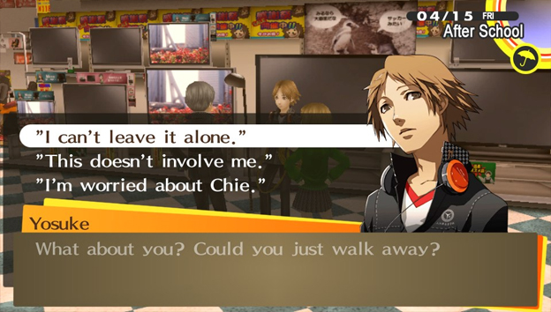

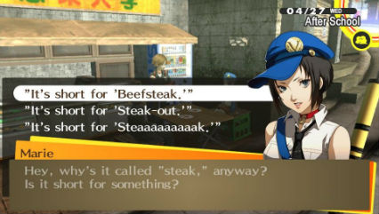

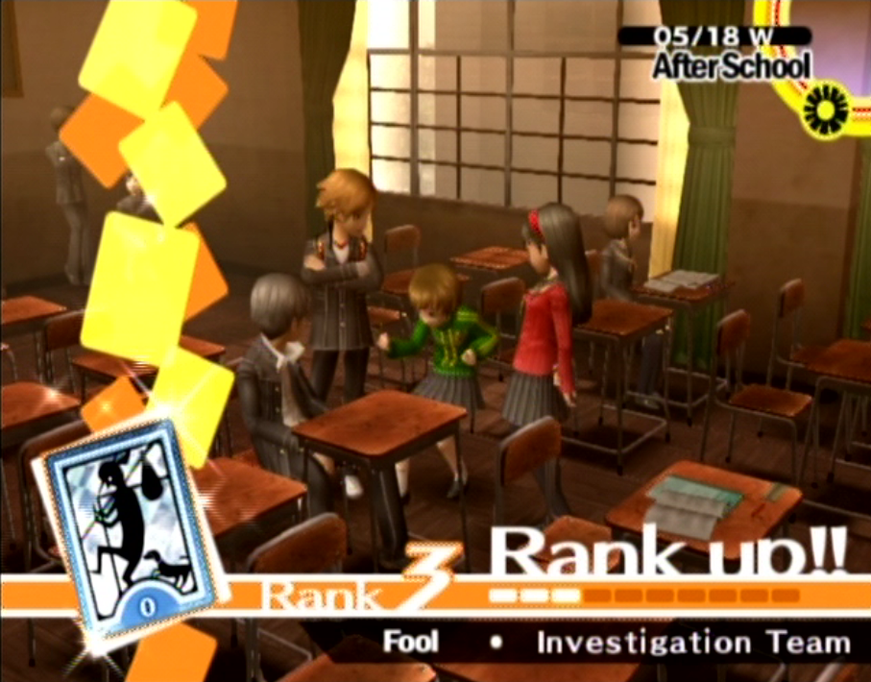

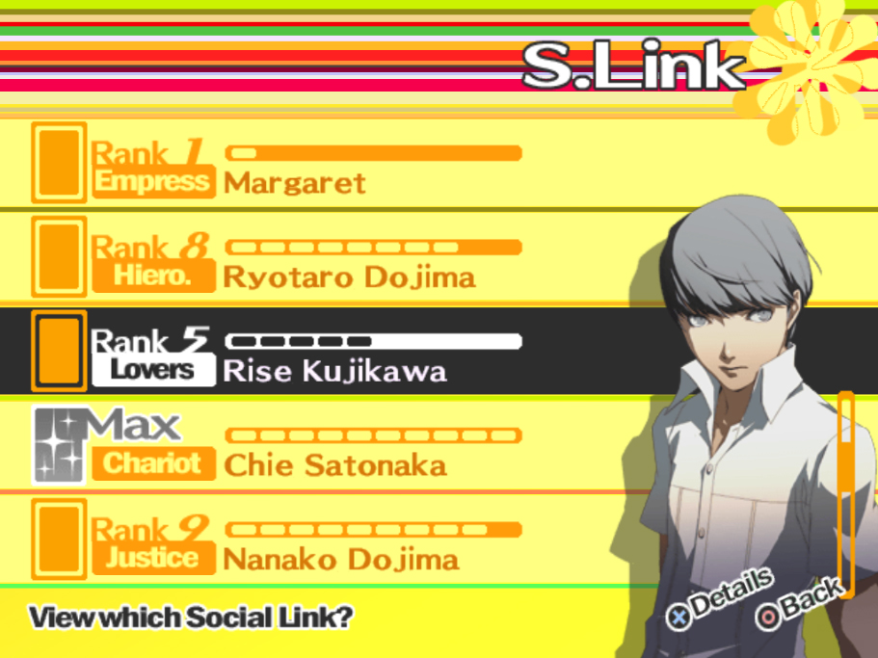

Persona 3 Portable

